Table of Contents
1. Assessment Protocol 2
1.1. Assessment Timeline 2
2. Better Cotton Registration 2
2.1. Better Cotton CoC Registration Process 2
2.2. Category Risk Level Assignments 2
2.3. Commissioning an Third Party Verifier (3PV) 3
3. IDFL Application 3
3.1. IDFL Services 3
3.2. Application Review 3
3.3. Agreement / Quotation 3
3.4. Pre-Assessment Documentation 4
3.5. Onsite Assessment 4
3.6. Corrective Actions 4
3.7. Assessment Decision 5
3.8. Assessment Validity 5
4. Better Cotton CoC Pre-Assessment Documentation Checklist 6
5. Better Cotton CoC Onsite Assessment Preparation Checklist 7
6. Appendix (Documentation Guidance) 9

Assessment Protocol

Assessment Timeline

Better Cotton Application |  |  |  | IDFL Application Process
Registration | Categorized  Risk Level | 3PV |  | Application | Review | Agreement | Pre-Assessment Documentation | Onsite Assessment | Corrective Actions | Assessment Decision
 | 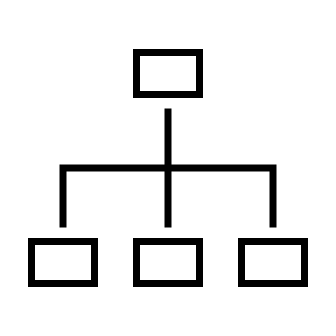 |  |  |  |  |  |  |  |  |   
Client fills out and returns to BC.  Could take up to 30 days.* |  |  |  | 1-2 Weeks* |  |  | 2-4 Weeks*  (Preparation) | 1 Day  per site | 30 days – 6 months*  (Preparation) | 10 Business Days
*This is the estimation according to BC. For more information, please contact Better Cotton. |  |  | *This is the average time period for client preparation and is dependent on the time it takes the client to prepare the necessary documents and actions to become certified. This time can be shorter or longer depending on client preparation.

Better Cotton Registration

Better Cotton CoC Registration Process

Organizations who are interested in BC CoC will need to fill out a registration form from BC. After BC reviews the registration application form, they will assign a Risk Category to the organization that has been approved for the Chain of Custody program.

- If you a Better Cotton RB Member, visit the myBetterCotton platform to find out more about how you can start sourcing Traceable Better Cotton.
- If you are a Better Cotton Supplier, you will first need to be onboarded to the Chain of Custody Standard. Log in to the BCP and click on ‘Complete the Chain of Custody Standard Registration Form’ to begin preparing to source Traceable Better Cotton. For more information about the onboarding process you can find it here.
- If you are new to Better Cotton, depending on your organization category, you may need to become a Better Cotton Member or just apply for a Better Cotton Platform account, find out more on BC Membership page.

For more information on Better Cotton Chain of Custody Standard visit the Better Cotton Traceability page.

*All supply chain organizations that are buying or selling physical Better Cotton or fulfilling Better Cotton Mass Balance orders. These include (but are not limited to) middlemen and markets for raw seed cotton, ginners, merchants, lint traders, mills with spinning capabilities, mills or suppliers without spinning capabilities (including fabric mills, dying mills, yarn and/or fabric traders, vertical mills), end-product manufacturers, sourcing agents, and retailers and brands with their own manufacturing capabilities.

Category Risk Level Assignments

The category could be amended at any point based on additional information discovered while an organization is in the Better Cotton program. The category can also be amended based on demonstrable adherence to the requirements of the CoC Standard and other normative documents.

- Category A - No initial assessment required before entering the program. Subject to ongoing monitoring activities. Assessment required within 3 years.
- Category B – A remote or on-site assessment is required within 12 months of entering the program. For Ginners this will depend on the season and will need to happen during a season.
- Category C - A physical on-site assessment by an approved Third-Party Verifier (3PV) is required before the site can start trading physically traceable Better Cotton. An on-site assessment is required every year. A category can be amended base on demonstrable adherence to the requirements of the CoC Standard and other normative documents.

Category A & B

Organizations in Category A or B will be invited to register on the Better Cotton Platform (BCP) and complete the relevant online BCP training modules. In addition to Category B, a list of approved 3PVs can be found on the BC website to arrange for an assessment within the 12 months in the program.

Category C

Organizations in Category C shall contact an approved Third-party Verifier (3PV) to arrange an assessment against the Better Cotton Chain of Custody (CoC) Standard v1.0. A list of approved 3PVs can be found on the BC website. Upon successful completion of the assessment the organization will be invited to register on the BCP and complete the relevant online BCP training modules.

Commissioning a Third Party Verifier (3PV)
2.3.1 Once BC has approved you into the CoC Standard program and has issued you a Risk Category you can now commission an Independent 3PV for your CoC Assessment.

2.3.2 The accompanying Independent Assessment for the CoC frequency requirement is based on the Risk Category you have been assigned. Please refer to Section 3.8.

IDFL Application

IDFL Services

Information regarding the standards and applications can be found on our website – www.idfl.com/services/audits-certifications/ or by email request. For any questions or assistance with the application, please contact us.

For contact information see our website: https://idfl.com/directory

Application Review

Upon receipt of the completed application, IDFL will review and contact you if further information is necessary. A conference call or in-person meeting may be necessary to confirm all application requirements.

Agreement / Quotation

Once all questions and concerns have been addressed and the scope of the certification confirmed, IDFL will issue an agreement and quotation for the certification services. The client is expected to review and formally sign the agreement before the evaluation may commence.

Pre-Assessment Documentation

After the agreement has been signed and payment has been received, the next step is to begin the pre-assessment documentation preparation. A document checklist and system plan will be provided to you. For some standards, IDFL may set up an IDFL Online Client Portal Account where you can upload, fill in, and submit online.

The documentation checklist is provided to you below for your reference – see Section B. Please note that the online checklist may have some minor differences.

Onsite Assessment

After the pre-assessment documents have been submitted and reviewed, IDFL can begin to schedule a date and time for an onsite assessment. To prepare for the onsite assessment, see Section C.

Corrective Actions

During the closing meeting of the onsite assessments or monitoring activities, the assessor will provide feedback and discuss any non-compliances (if any). For any non-compliance, a non-compliance report (NCR) will be issued to the organization. Corrective Action Plan (CAP) must be submitted (via IDFL Client Portal Account) by the organization within 10 working days after receipt of the final assessment reports. Corrective actions must be implemented within the specified timeframe below. If the organization fails to submit their CAP within the timeline, Better Cotton will temporarily suspend their BCP account until it provides a valid reason for delay or submits the CAP. Corrective actions should be submitted via IDFL Client Portal. Necessary corrective action plans will need to be in place before certification can be approved.

The CAP shall include a description of:
- The root cause of the non-conformity.
- The corrective actions intended to correct the non-conformity.
- An appropriate timeframe to implement corrective action (within the timeframes outlined below).

Minor NCs

Shall be corrected within 6 months or, for ginners, before the start of the next ginning season (whichever is shorter) and provide evidence to Better Cotton or the third-party assessor demonstrating how the issue has been addressed. If not addressed within 6 months or before the new season, a Minor NC shall escalate to a Major NC and the timelines for a Major NC shall be followed.

Major NCs

Shall be corrected within 30 calendar days of receipt of the final assessment report and provide evidence to Better Cotton or the third-party assessor demonstrating how the issue has been addressed. If not addressed within 30 calendar days, a Major NC shall lead to the suspension of their BCP account. The duration of a suspension period will be defined by Better Cotton considering the response to the NC.

The role of assessors is to ensure that organizations:
- are aware of the requirement of submitting CAP for their NCs.
- the information required in completing the CAP is sufficient.
- submit CAP to Better Cotton or the Third-Party Verifier within the required timeframe.
- are aware of the specified timelines for closing major and minor NCs, and the consequences of not meeting these NCs.

Assessment Decision

When all corrective actions are completed, the results are provided to an IDFL assessor. The results are carefully reviewed, and a final assessment decision is made.

Assessment Validity

Better Cotton CoC Standard Assessment is valid according to the Assessment Cycle* the organization has been assigned by Better Cotton. The validity operates on a 3-year assessment cycle and will restart on year 4. Organizations will need to re-submit their registration form to Better Cotton for renewal, starting in year 4.

Assessment Cycles
*Better Cotton reserves the right to amend the category based on various factors.

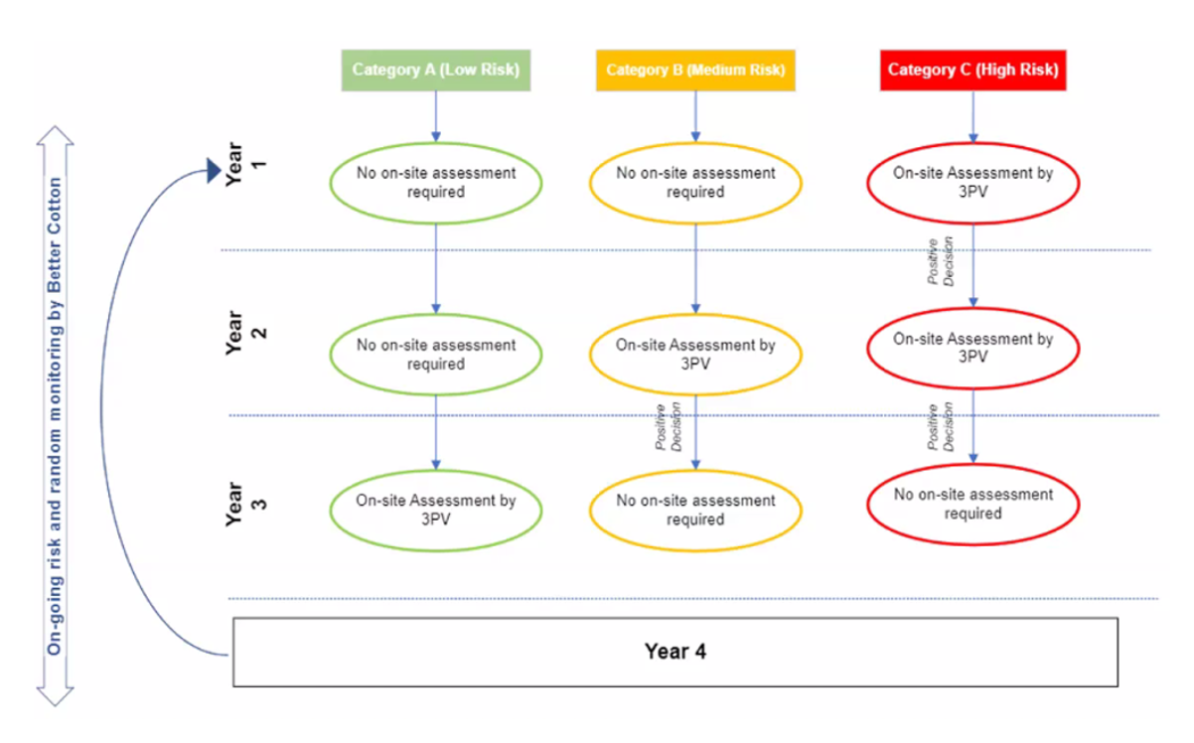

Better Cotton CoC Pre-Assessment Documentation Checklist

The following pre-assessment documentation must be completed and submitted to IDFL before the onsite evaluation can be scheduled.

No. | Documentation | Guidance (if any)
1 | Training participation records within the 12 months | Staff and temporary workers.
2 | Any previous non-conformities (NCs)
3 | Any prior complaint received
4 | Relevant outputs from the Self-Assessment
5 | Names of subcontractors (where applicable)
6 | Better Cotton CoC Management Plan / Production Manual
7 | Processing records including conversion rate
8 | Traceability, purchase/sales procedures, and purchase/sales record
9 | Mass Balance Sheet / Volume reconciliation records | Invoices, purchase orders, inventory reports, bill of lading, processing records/production logs, shipping documents, sales contract, annual volume summary reports,
10 | Contracts with subcontractors and details of the subcontracting activities (if applicable)
11 | Floor Layout
12 | Better Cotton CoC Material / Process Flow Chart
13 | Competence of the staff and temporary workers.
14 | For ginner only: gin agreement

Better Cotton CoC Onsite Assessment Preparation Checklist

In addition to the pre-assessment documentation, a site tour and the following documents, records, and preparation should be prepared during the onsite evaluation to demonstrate compliance to Better Cotton CoC Standard requirements.

C.1 On-site Tour
2.1 General Requirements | Guidance (if any)
The organization shall implement and maintain a documented management system, applicable to the scale and complexity of the organization’s operations. | Organizations should have a clear, consistent and documented management system. This may be embedded within broader management systems, particularly when organizations are verified to other CoC Standards e.g. CCS, GOTS or other quality management systems.
Training records of staff and workers. | Up-to-date and evidenced records.
The organization shall maintain sufficient infrastructure and technical resources | Infrastructure refers to physical infrastructure (e.g. warehousing capabilities, production lines, IT systems). The organization should demonstrate there is sufficient space, storage and resources to implement the CoC. Resources may include personnel, tools, equipment or external support to implement the CoC.
The assessor shall interview responsible personnel (management, administrative staff and workers) to verify competency in understanding and applying the relevant CoC Standard. | - The personnel responsible for the overall implementation of the CoC Standard.  - The personnel responsible for critical control points and areas of risk identified.  - Processing and handling activities in the operation during the assessment.  - The open non-conformities from previous assessments (if applicable).  - In case the activities at an organization (e.g., ginner) depend much on the use of temporary and/or seasonal workers, the assessor shall make its best effort to have the highest estimated number of temporary and/or seasonal workers present during the onsite assessment.  The number of interviews carried out shall reflect the size of the organization.
The organization shall maintain accurate, complete, up-to-date, and accessible records covering all aspects of this Standard. The records shall be applicable to the scope of the organization’s verification. The organization shall maintain all applicable records for a minimum of two (2) years. | Records shall include but are not limited to: Purchase orders, Supplier delivery notes, certificates of origin and invoices, Raw material stock records, Production records, Finished goods stock records, Sales and distribution records, Stock reconciliation records
The organization shall have a procedure for the handling and resolution of complaints relating to the implementation of the CoC Standard.
Maps / Diagram Layout of Processes and Storage Areas for Better Cotton Materials / Products
Processing records including conversion factors,  packing slip, and transaction certificates. | Volume summary report, invoices, sales receipts
Contracts with subcontractors and details of the subcontracting activities (if applicable) | Up-to-date, relevant, and well-managed subcontracting agreements
Mass Balance Sheet / Volume reconciliation records | Up-to-date, relevant, and well-managed subcontracting agreements
Traceability and segregation systems, purchase/sales procedures, and purchase/sales records | Identification systems e.g. signs, color coded systems, barcodes, chalkboards
Site inspections shall cover, but not be limited to locations where there are workers performing key processing activities directly related to the verification scope.

Appendix (Documentation Guidance)

IDFL has prepared the following appendices to help in the preparation of the BC CoC Standard documentation. Each appendix references a specific document / manual and includes the suggested sections (information and/or procedure) that should be used to prepare the document. Please note, the list of sections is for reference only – some may not apply. IDFL will provide a more detailed list upon confirmation of service.

BC CoC Management System / Production Manual Guidance
Section - Information and/or Procedure | Guidance
Company introduction
Organizational chart (including appointment of BC management representative and all other important roles and responsibilities)
Management system
- Control of documents
- Control of records
- Internal audits
- Management review
Staff training procedure
BC purchasing and supplier evaluation procedures | This should include requirements for obtaining transaction certificates
BC input (incoming material) inspection | This should include procedure for inputs that are suspected of non-compliance.
BC sales procedure
Subcontractor management procedure
Records of Subcontractor Contracts / Agreements
Production management
- Production Order/Records procedure
- Internal Traceability
- Chemical Use
- Volume Reconciliation
- Cleaning procedure
Quality management procedure
Storing procedure, packings procedure, transportation procedure.
Records of raw material inspection
Transporting procedure
Volume reconciliation review and management
Demonstration of BC signage to indicate “BC Materials” / “BC Products” for storage areas or other methods of segregation (bag / box color, special tags, stickers, etc.)
Demonstration of internal BC identification, such as tags and labelling methods with product description, batch numbers, production lots, etc.
Demonstration of identification and segregation of “BC products in processing” such as signage on machines to ensure no commingling with non-certified products.
Calibration records of scales, measuring devices, and testing equipment
Inventory / stock records
Handling client complaints
Training records
Continuous improvement

